

Course Name and Number: DATA 604, Simulation and Modeling Techniques

Credits: 3

Prerequisite: DATA606, Statistics and Probability for Data Analytics

Course Description:

This course teaches students the basics of simulation, systems modeling, and related software applications. The objective is to introduce students to the theory, statistical aspects, and implementation of computational methods for stochastic simulation and event-driven systems modeling. Students will be exposed to topics such as random sampling, Monte Carlo integration, variance reduction, Markov methods, queuing theory, discrete-event systems simulation, input/output data analysis, and simulation-based optimization. Students will develop a contextual understanding of simulation and modeling techniques by implementing the covered methods.

Learning Objectives:
- Create Simulation Models
- Evaluate Simulation Models
- Certify on Simulation Software

Program Learning Outcomes/Competencies addressed by the course:
- Business Understanding. Apply frameworks and processes to build data-analytic solutions from an understanding of business goals.
- Data Programming. Use industry standard statistical tools and simulation packages.
- Foundational Math and Statistics. Emphasis on probability, statistics, and computational methods.
- Data Understanding. Collect, describe, model, explore and verify data.
- Prescriptive Modeling. Selecting prescriptive modeling techniques, generating test designs, building and assessing models.
- Model Implementation and Deployment. Students will learn to implement simulation models for the various prescriptive modeling techniques covered in the course.
- Presentation. Students will deliver presentations of their project results.

How is this course relevant for IS and data analytics professionals?

Simulation and modeling techniques are essential skills in today’s data-driven business environment where there is inherent uncertainty embedded in real-world decision-making processes. The material covered in this course lies at the heart of prescriptive data analytics, which suggests decision options on how to take advantage of a future opportunity or mitigate a future risk, while showing the implication of each decision option.

Assignments and grading:

1. Assignments: During the course, you will be completing a series of individual lab assignments. Your final assignment is the design and presentation of a simulation representing a pre-approved project. This assignment will include the simulation code, a presentation, and a paper.
2. Examinations: This course has no examinations.
3. Grade Evaluation: Grades in this course are determined by the percentage of points obtained.
Assignment | Percentage
Homework, Submitted to Blackboard | 52% (13x 4% each)
Discussion Contribution | 13% (13 x 1% each)
Final Case | 35%
Total | 100%
4. Grading Rubric: The grading rubrics follow.
- Each homework will be graded as {zero, check minus, check, and check plus}. The associated grades are {0%, 3%, 4%, 5%}. (1% and 2% are reserved for incomplete attempts or lack of effort.)

- The final case rubric will be posted to Blackboard.

- Discussions are applied analysis from the texts. You must post a response by Wednesday at midnight (ET) and respond to at least one of your colleagues’ contributions, providing meaningful feedback on the analysis.

5. Late Policy for Homework: Late work is penalized 5% per day for all work other than the final simulation. Late portions of the final simulation are awarded zero credit. All assignment due dates and times are shown in Blackboard.

6. Grades: I assign grades based on the following table.
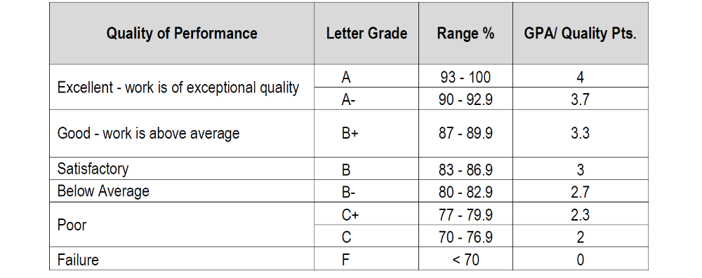

Course Materials:
Required Textbooks:

Simio and Simulation: Modeling, Analysis, Applications 3d Ed. by W. David Kelton, Jeffrey S. Smith and David T. Sturrock with Simio software. This book is available for purchase ONLY online.

Version | ISBN-13 | ISBN-10 | List Price
Color Interior | 978-1-49-2116424 | 1-49-211642-4 | $79
Grayscale Interior | 978-1-49-3616206 | 1-49-361620-X | $39
Color E-book | TBA | TBA | $29

Statistical Computing with R (2008), by Maria L. Rizzo. ISBN 1-58488-545-9

Discrete-Event Systems Simulation, 5th Edition (2010), by Jerry Banks, John S. Carlson, Barry L. Nelson,and David M. Nicol. ISBN 078-0-13-606212-7

Simulation Modeling with SIMIO: A Workbook (2012), by Jeffrey A. Joines and Stephen D. Roberts. ISBN978-1-938207-76-1

Recommended Textbook:
Simulation, 5th Edition (2013), by Sheldon M. Ross. ISBN 978-0-12-415825-2

Course Meeting Time:

Every other week on Thursday from 8-9 pm. The following schedule applies.

8/31, 9/14, 9/28, 10/12, 10/26, 11/9, 12/7
https://bccte.zoom.us/j/708754548

COURSE OUTLINE

Week of | Topics covered (S=Simio by Kelton, SCR=Statistical Computing with R, D=Discrete Event Simulation textbooks, J=Simio by Joines)
25 August  (Week 1) | Topic Title: Introduction to Simulation  Reading: S1, J1 / J2, Scan D1 and SCR1  Homework:  1) Submit a document verifying that you have successfully installed and tested Simio. 2) Provide a paragraph telling me what you want from this course.﻿﻿﻿﻿﻿﻿﻿﻿﻿  Topics covered  - Systems & Models  - Randomness & Simulation  - When to Simulate (and When Not to)  - Simulation Success Skills
4 Sep  (Week 2) | Topic Title: Basics of Queuing Theory  Reading: S2, D6, Scan SCR2 (Review of Prob & Stats)  Homework: S2 problems 2, 3, 5, 12  Topics covered  - Queueing Structure & Terminology  - Little’s Law  - Specific Results for Multiserver Queuing  - Queuing Networks  - Queuing vs. Simulation
11 Sep  (Week 3) | Topic Title: Kinds of Simulation  Reading: S3, Scan SCR 5-9 and D7-8 (We read them later.)  Homework: S3 problems 1, 5 and 17.  Topics covered  - Classifying Simulations  - Static Stochastic Monte Carlo  - Dynamic Simulation  - Software Options
18 Sep  (Week 4) | Topic Title: First Simio Models 1  Reading: S4, D4, D8, SCR3,  Homework: S2 problem 9 followed by S4 problem 1 and problem 15  Topics covered  - Basic Simio User Interface  - Model 4-1  - Model 4-2  - Model 4-3 (ATM)
25 Sep  (Week 5) | Topic Title: First Simio Models 2 / Random Number Generation  Reading: S4, D7  Homework: S4 problems 2, 3, 9, 12  - Simio Plots  - Exporting Data  - Basic Model Animation  - Model Debugging
2 Oct  (Week 6) | Topic Title: Intermediate Modeling with Simio 1 / Random Variate Generation  Reading: S5, SCR3, D8  Homework: S5 problems 1, 2, 3, 4, 5  Topics covered  - Simio Framework  - PCB Assembly  - Enhanced PCB Assembly
9 Oct  (Week 7) | Topic Title: Intermediate Modeling with Simio 2  Reading: SCR5  Homework: S5 problems 6, 7, 8, 9  - PCB Model with Process Selection  - Comparing Multiple Alternative Scenarios
16 Oct  (Week 8) | Topic Title: Input Analysis / Variance Reduction Methods  Reading: S6, J3  Homework: S6 problems 1, 2, 3, 4, 5, 8  Topics covered  - Specifying Univariate Distributions  - Types of Inputs  - Random Number Generators  - Generating Random Variates and Processes
23 Oct  (Week 9) | Topic Title: Working with Model Data / Monte Carlo Methods  Reading: S7, SCR 6-7  Homework: S7 problems 6, 7, 8  Topics covered  - Data Tables (ED Example)  - Schedules  - Rate Tables  - Lookup Tables  - List and Changeovers  - State Arrays  - Macro Modeling
30 Oct  (Week 10) | Topic Title: Animation and Entity Movement / Markov Chains  Reading: S8, SCR 9  Homework: S8 problem 5  Topics covered  - Animation  - Entity Movement
6 Nov  (Week 11) | Topic Title: Advanced Modeling with Simio 1  Reading: S9  Homework: S9 problem 2  Topics covered  - ED Model Revisited  - Pizza Takeout Model  - Fixed Capacity Buffers
13 Nov  (Week 12) | Topic Title: Customizing and Extending Simio  Reading: S10  Homework: S10 problem 1  Topics covered  - Basic Concepts  - Building a Hierarchical Object  - Building a Base Object  - Sub-classing an Object  - Working with user extensions
20 Nov  (Week 13) | Topic Title: Customizing and Extending Simio Part 2  Reading: S10  Homework: None  Topics covered  - Building a Base Object  - Sub-classing an Object  - Working with user extensions
27 Nov  (Week 14) | Topic Title: Model V&V / Optimization  Reading: Scan J4-5, J10-11, J16, D10-12  Homework: Submit Simio Level 1 Certification Certificate  http://www.simio.com/resources/online-training/introduction-to-simulation-and-scheduling-level-1-certification.php  Topics covered  All
4 Dec  (Week 15) | Topic Title: Final Project Presentations / Submission  Topics covered  All

